

F

Fitness Tracker

System Requirements Specification Document v 1.0

Table of Contents:

1.
Introduction 3
1.1 Scope: 3
1.2 Management Summary 3
1.3 Definitions 3
1.4 Overview 3

2.System Objectives / Overview 4
Figure 1 System Context Diagram 4

3.Functional Requirement 6
3.1 Brief Description 6
3.2 Interface Details 6
3.3 Table of requirement 6
Figure 2 Application Flow Diagram 4

4.Database Schema: 8
SQL Script for table creation: 8

Introduction

Scope:

This document describes the scope of the requirements for the Fitness Tracker for Abc Corporation The document details all the high level requirements with intent to validate Abc’s requirements. This document should be used by the Architect and the developers to design the Solution Architecture for the project.
The key system that is involved in the integration is Fitness Tracker.
The list of priorities of Fitness Tracker is:
- User Registration and Login
- Workout Tracking on per day basis
- Providing RSS Feed
- Providing personalize coach

Management Summary:

ABC Corp is a Private organization which provides healthy food and workout routines on the basis of person’s BMI and his/her daily routine. Fitness Tracker is a online platform which will take user’s data and on the basis of his/her BMI will provide daily workout exercises and meal. It will also provide personalize coach which is a paid service if any user wants. It will also track user’s daily workout and will provide them graphical report.

Definitions:
- Spring Boot: For developing Microservices(Middleware)
- My sql: For developing database for storing all data(Back end)
- Angular: For developing functional Web pages(Front end)
- Bootstrap: For designing user interface

Overview:
This Document will describe all the main requirements that will require to develop this application. Specifically it will outline the type of database used, technology used for front end, back end and user interface. It also outlines the infrastructure and working of application.

System Objectives

Middleware
(Spring Microservices)

User Interface
(Angular)

User

Data
Base

Figure 1 System Context Diagram

The diagram above explains the main conceptual elements in the solution and its
relationships with the architecture. A user first interacts with user interface which will process the request to Spring microservices which will further insert the data to database .In response data will be checked in database and return the response to user interface.

Fitness Tracker | Core application that’s is to be developed for providing workout routine to the user including daily exercises and meal for the day. It also track the user’s workout and provide the graphical report. It also provides the personalize coach which is a paid service.
User Interface  Middleware  Database | It is a angular application in which user fills out the data and can view all exercises and meals for the day, evaluate workout ,view graphical report and view profile.  Spring Microservices are used as middleware.  My sql database is used to store all user  Data and for storing exercises and routines.

Functional Requirements

Brief Description
The fitness tracker will take the basic user detail i.e. his height and weight and using that detail it calculates his B.M.I. And according to the B.M.I it classifies the user into one of the 12 category mentioned and suggest him the diet and proper exercises for a month to be fit.

3.2 Interface Details
Pls see the System Objective diagram.

3.3 Table of requirement
Flow | The Fitness Tracker will first provide an interface to user to signup either as a paid customer or free user.  After signing up Fitness Tracker ask user for height and weight and using that detail it calculates his B.M.I. And according to the B.M.I it classifies the user into one of the 12 categories mentioned and suggest him the diet and proper exercises for a month to be fit.  Fitness Tracker also keep the daily track of the user exercise and it provide a functionality where the user can daily feed his data regarding the exercise i.e. how much exercise he done. And the Fitness Tracker will show him what his daily progress by showing the graph of expected vs exercise done by the user.

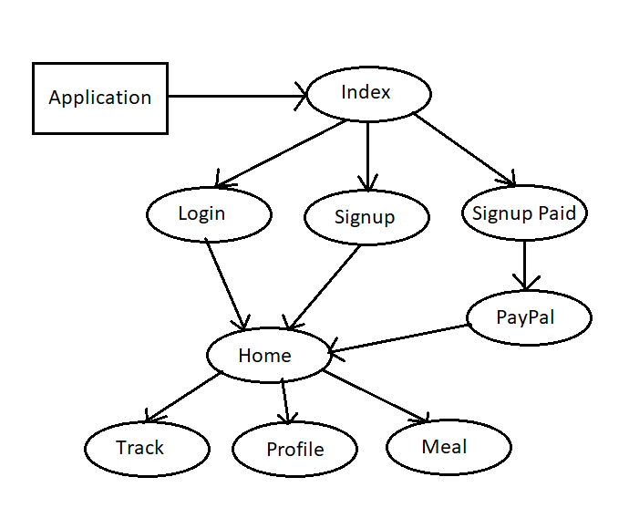

Figure 2 Application Flow Diagram

Database Schema:

There is a total of 13 table which the Fitness Tracker use to save and display data. One table is for saving the User detail who are registering for the first time on the Fitness Tracker website. Rest 6 table have the data of exercises for different categories male and female according to B.M.I. And the remaining 6 tables has data of meal of the respective categories.

